
phgy311
lecture #: | date: | professor:
21 | Nov. 1, 2006 | Dr. Haghighi
22 | Nov. 3, 2006 | Dr. Haghighi
announcements:

Edited By: Steph Rolin
Do Not Redistribute.
set #7
PHGY 311 – Lecture 21 November 1, 2006
Writer: Queenie Chow Dr. Haghighi

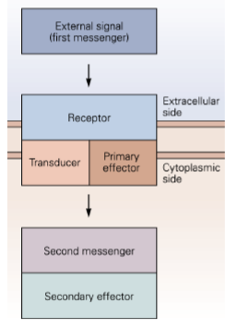
METABOTROPIC RECEPTORS
- Metabotropic receptors could be present at any synapse
  - Depending on the site of metabotropic receptor action, these receptors can give rise to different effects.
- In general, the different metabotropic receptors share a basic, common molecular logic: the response of metabotropic receptors is an increase in secondary messengers, acting on second effectors.

- Activation of ionotropic/metabotropic receptors can turn on secondary messengers, which can turn on kinases and have short term effects (e.g. affect receptors or ion channels), or long term effects (i.e. affect gene transcription through transcription factors in a downstream cascade).

EXAMPLES
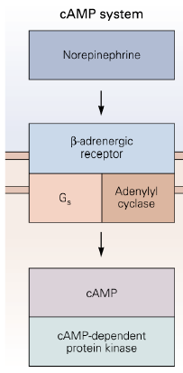
- cAMP system
  - Primary messenger activates the β-adrenergic receptor, which activates G_{s}, which activates adenylyl cyclase.
  - cAMP levels in the cell increases, which activates cAMP-dependent protein kinase (aka. PKA).
    - An increase in PKA could increase phosphorylation of ion channels, affecting membrane properties.
- Phosphoinositol system → see “Muscarinic ACh receptors” later in this lecture
- Arachidonic acid system → see “Histamine receptors” later in this lecture

PROTEIN KINASES
- A protein kinase is a kinase enzyme that acts by phosphorylating other proteins.
  - Phosphorylation results in a functional change of the target protein.
- Kinases regulate most cellular pathways, especially those involved in signal transduction.
  - They act by removing a phosphate group from ATP and attaching it to an amino acid with a free hydroxyl group (serine, threonine, and/or tyrosine).
- Kinases are activated and deactivated by phosphorylation.
  - Can auto-phosphorylate, or be phosphorylated by binding activator or inhibitor proteins.

- There are several families of protein kinases.
  - cAMP-dependent protein kinase, aka PKA
    - This is a family of enzymes whose activity is dependent on intracellular cAMP levels.
    - PKA has 2 regulatory and 2 catalytic subunits. When cAMP levels are low, PKA is catalytically inactive. When cAMP levels rise, (through GPCR, adenylate cyclase, inhibition of phosphodiesterases), these molecules bind to binding sites on the 2 regulatory binding sites. This causes a conformational change, and the catalytic subunits are released.
    - Once the catalytic sites are released, they phosphorylate serine or threonine residues.
    - Usually the effects are transient, as protein phosphatase quickly depohsophorylate the targets of PKA.

  - cGMP-dependent protein kinase
    - This is a serine/threonine-specific protein kinase.
      - Involved in: smooth muscle relaxation, platelet function, sperm metabolism, cell division, and nucleic acid synthesis.
    - The kinase activity of this kinase is suppressed in the absence of cGMP. Once cGMP binds to the regulatory sites, there is a conformational change which releases the inhibition of the catalytic core. This allows phosphorylation of substrate proteins.

  - Protein Kinase C
    - This is a group of protein kinases that require calcium, diacylglycerol (DAG), and phospholipids in order to be activated.
    - The substrates upon which PKC works includes MAP kinase, transcription factor inhibitors, and growth factor receptors.

  - Ca²⁺/calmodulin-dependent protein kinase (CaM)
    - These are serine/threonine-specific proteins kinases. They are primarily regulated by the calcium/calmodulin complex.
      - Upon increase in intracellular Ca²⁺ concentration, Ca²⁺ binds and activates calmodulin, calmodulin binds and calmodulin-dependent protein kinase.

    - In the absence of calcium/calmodulin, the catalytic domain is autoinhibited. When they are activated by calcium/calmodulin, activated CaM kinases auto-phosphorylate each other. This allows it to have long-term effects (20-30min) as it:
      - Prolongs the amount of time the kinase is active.
      - Allows CaM to continue working, even after the calmodulin complex has dissociated from the kinase complex.

    - CaMs phosphorylate downstream effectors, which could be ion channels, or downstream signaling molecules for regulation of gene transcription.
      - These kinases are especially important for long-term synaptic modulation (LTP).
    - CaMs are turned off by phophatases and unknown protein-protein interactions.

  - Tyrosine Kinase
    - These are enzymes that transfer a phosphate group from ATP to a tyrosine residue.
      - Different as they are directly activated and auto-phosphorylate each other.
    - There are two groups of tyrosine kinases: cytoplasmic proteins and transmembrane receptor-linked kinases.
      - The hormones and growth factors that act on cell-surface tyrosine kinase-linked receptors are usually growth-promoting and work to cause cell division.

DESENSITIZATION
- Desensitization is the progressive inactivation of a receptor due to prolonged exposure to a transmitter
  - A simple explanation for desensitization: closure of receptor, or decrease in response of receptor to transmitter.
  - If receptors are desensitized, the EPSPs will be smaller in either amplitude or duration.
- Phosphorylation of ACh receptors can lead to increased desensitization.
  - Desensitization is a kinetic term. It affects the gating of ACh receptors by shortening the duration of a single channel opening.
  - Macroscopically, on an I vs. time graph showing the current change due to the opening of single ion channels in a patch clamp, the number of opening channels observed would decrease.

- The conductance of the single channel due to desensitization has not changed, but the probability of its opening has changed. For the sake of this course, we say that desensitization affects the mean-opening time and the probability of the ion channels, both individually and as a population of ion channels. (These two are hard to distinguish.)
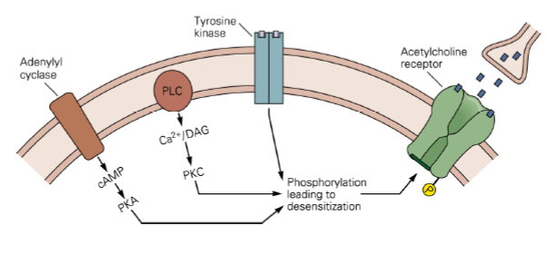

- This figure shows three different kinases, activated by different metabotropic receptors, all acting on the same ACh receptor. The pathways of the different metabotropic receptors interact with each other. The activation of these receptors eventually leads to desensitization of the ACh receptor.

- This channel is not being blocked by something. Single channels don’t open for a long period of time; if the probability of one single channel opening is decreased, the probability of two channels coincidentally opening is also decreased. K+ channels generally open for a long time.

MUSCARINIC RECEPTORS AND PKC
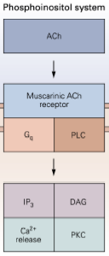
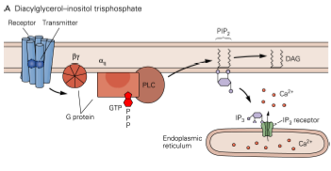
- Muscarinic receptors activate PKC
- Note that while both nicotinic and muscarinic receptors are activated by ACh, nicotinic are ionotropic whereas muscarinic are metabotropic.
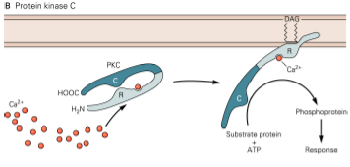
Upon activation of the muscarinic receptor, hydrolysis of phospholipids initiates 3 secondary messenger cascades:
- G-coupled protein receptor is activated, which activates PLC (phospholipase C).
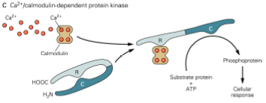
- PLC hydrolyzes phospholipids, namely PIP₂, which produces IP₃ and DAG, two secondary messengers.
- IP₃ (second messenger #1) activates intracellular calcium release from the endoplasmic reticulum. Calcium becomes the third secondary messenger. (Note: Of these 3 secondary messengers, Ca²⁺ is most involved in other cascades.)

- DAG (second messenger #2) is membrane-bound. PKC binds to DAG to be activated. Some isoforms of PKC also require Ca2+ for activation, but the critical step is PKC binding to DAG.
- The activated PKC can now phosphorylate substrates in ATP-dependent reactions.
- Calcium (second messenger #3) binds and activates calmodulin. Calmodulin then binds to the regulatory subunit of calcium/calmodulin-dependent protein kinase and activates it.
- Remember that Ca/calmodulin-dependent protein kinase is a multi-subunit protein (not shown in diagram). They can phosphorylate other substrates as well as auto-phosphorylate, making itself calcium-independent for long-term effects.
- As you can see, muscarinic receptor activation can lead to a lot of cascade changes in the cell.
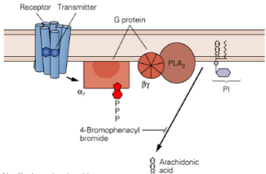
HISTAMINE RECEPTORS
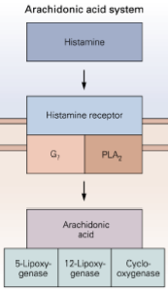
- Histamine receptors produce arachidonic acid
- The arachidonic acid system also involves a G-protein cascade.
  - Histamine binds to its receptor, which activates a G-protein cascade, which activates PLA₂ (phospholipase A₂).
  - PLA₂ hydrolyzes PI (phophatidylinositol), producing arachidonic acid, which leads to a lot of cascades.

MUSCARINIC RECEPTORS
- Muscarinic and ionotropic receptors are often both present at autonomic ganglion synapses.
  - When you record EPSP from there, you observe a fast EPSP and slow EPSP.
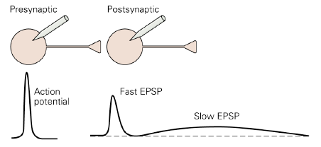

- Slow EPSPs are smaller in amplitude but longer in duration than fast EPSPs.
- Slow EPSP are due to the activation of muscarinic ACh receptors; fast EPSPs are due to the activation of nicotinic ACh receptors.
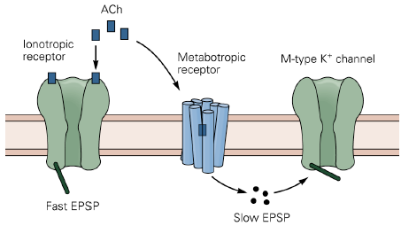

- Muscarinic receptors (through secondary messengers) close M-type K⁺ channels (or lowers the probability of the M-type channels will open).
- The closure of the M-type K⁺ channel leads to the generation of the slow EPSP:
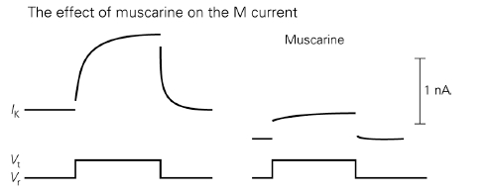
- When M-type channels close, outward K⁺ flow is decreased.
- Continual small Na⁺ influx leads to net inward current.
- Depolarization continues until the decrease in K⁺ conductance (due to M-type channel closure) is offset by increase in outward K⁺ driving force (due to influx of Na⁺). Equilibrium is reached when I_{K,out} = I_{Na,in} once again.
- The slow depolarizing current caused by muscarinic receptors increases the cell’s excitability.

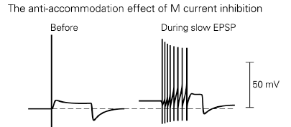
- The figure to the right shows the effect of applying the same stimulus to a cell before and after the closure of M-type K+ channels.
  - In normal conditions, if no muscarinic receptors are activated (i.e. M-type K⁺ channels remain open), an autonomic neuron will fire only once, even in response to rapid pre-synaptic stimulation. The K⁺ current stops the cell from firing any more than that.
  - If muscarinic receptors are active, the K⁺ channels are closed, then the cell can fire a lot more. Since muscarinic receptors cause a slow depolarizing current, the cell is much more excitable.

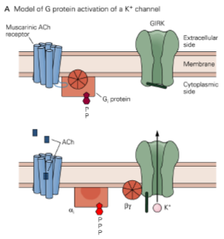
Direct activation of another type of K⁺ channel by muscarinic receptors
- G protein-coupled, inward-rectifying K⁺ (GIRK) channels are directly activated by G-proteins.
  - Doesn’t require a secondary messenger, but requires the muscarinic receptor and K⁺ channel to be close.

- In the previous mechanism involving secondary messengers, we could experimentally inject a cell with a secondary messenger and get a response in a patch. Here, we would have to catch the muscarinic receptor WITH the K⁺ channel in a patch inside pipette to get a response.
  - The G-protein must interact directly with the K⁺ channel to activate it.
- Note that here we’re talking about inward K⁺ currents.

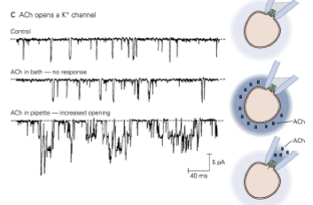
- The patch clamp experiments here contain an ACh receptor and a GIRK channel under the patch.
  - The middle graph shows that a cell bathing in ACh solution outside of pipette has no effect on the opening/closing of the GIRK.
  - If ACh was present inside the pipette, then channels were activated.

- Note that the [K⁺] inside the patch pipette was very high in this experiment, hence an inward K⁺ current is possible. Ion channels are dependent on the concentration gradient.

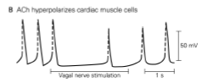
- Muscarinic receptors are present on the heart muscles.
- By giving rise to K⁺ current and hyperpolarizing the cell, they slow down the heart.
- This is interesting because it seems as if muscarinic receptors are involved in two contradictory mechanisms. In the last slide, the muscarinic receptor depolarized the cell, allowing it to fire faster; here, it decreases firing. This shows that here is no hard-and-fast rule. The same player in different biological conditions could have very different effects. Only experimental results would show what is actually happening.

Phosphatases counteract the action of kinases
- How do proteins such as Ca/Calmodulin-dependent kinases shut down? When proteins are phosphorylated, they’re usually shut down by phosphatases.
- There are other mechanisms can inactivate a protein, e.g. ubiquitination leads to degradation/modulation of a protein.
- In this case, PKA opens the K⁺ channel (Unlike earlier desensitization example, where phosphorylation closed K channels. It again goes to show that phosphorylation doesn’t always close channels)

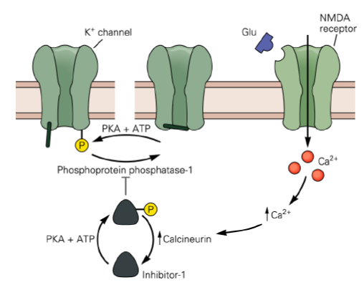
This diagram shows that phosphorylation and dephosphorylation of a K⁺ channel are controlled by protein kinase (i.e. PKA) and phosphatase (i.e. phosphoprotein phosphatase-1) respectively.
  - Inhibitor-1 inhibits phosphoprotein phosphatase-1
  - Calcineurin dephosphorylates Inhibitor-1
  - Overall: Increase in intracellular [Ca²⁺] through NMDA receptors activates calcineurin, which dephosphorylates Inhibitor-1; this increases phosphatase-1 activity, and results in reduced phosphorylation of K-channels.

- Note that PKA is working in 2 different places to help itself: by phosphorylating Inhibitor-1, it inactivates phosphatase, the counteractive protein, so that it can continue to phosphorylate K⁺ channels.

PHGY 311 – Lecture 22 November 3, 2006
Writer: Renata Sasson Dr. Haghighi

Myasthenia Gravis
- Myasthenia gravis is an autoimmune disease that affects neurotransmission at the NMJ.
  - The primary cause is an autoimmune response against the body’s own ACh receptors at the NMJ.

- People used to die from this disease, but now there are many measures available to keep it under control.
  - Anti-cholinesterase is used to treat the symptoms because it prolongs the availability of ACh
    - Normally, this enzyme breaks down ACh in the synaptic cleft.
- Most people with this disease still die eventually from respiratory failure (those muscles also end up failing).
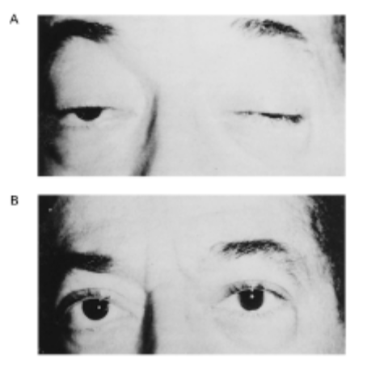

- Warning signs include muscle weakness and fatigue, especially in cranial and facial muscles.
- This is demonstrated in the pictures on the left.
  - A is a patient before treatment. Notice he can barely open his eyes
  - B is a patient after treatment. Obviously he’s doing much better.

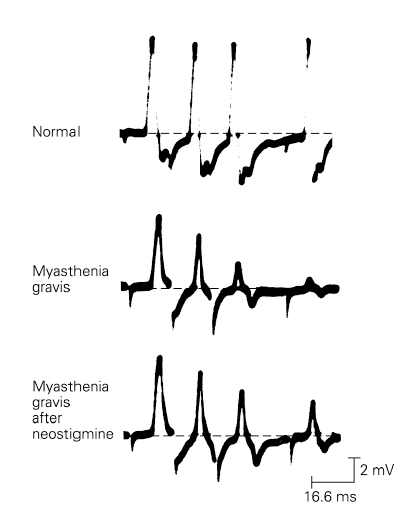

Action Potentials in Myasthenia Gravis
- In normal muscles, every time you stimulate the motor neuron, you get an AP in the post synaptic muscle.
- In myasthenia gravis muscles, however, repeated stimulation causes a quick decline in postsynaptic APs and eventually ends in failure of the synapse. (see middle of picture)

- Note that in the diagram to the right the APs are of different amplitudes in the disease-stricken muscles.
  - This is because the graph is shows compound action potentials, obtained by recording from hundreds of muscle fibers simultaneously.
    - Unlike single channel AP amplitude, the amplitude here is an average of all the recordings (lower amplitudes result from averaging in failed synapses).

Safety Factor for SynapticTransmission
- Defined: The difference between the threshold and the actual end-plate potential amplitude
- There is normally a large safety factor at the vertebrate NMJ.
  - You can reduce the amount of ACh release more than 50% and the muscle still fires an AP (see figure A below)
  - A lot more NT is released than is needed.

- In a myasthenic muscle, the safety factor has been abolished due to the depletion of ACh channel destruction.
  - Consequently, the muscle sometimes fails to fire (see figure B below)
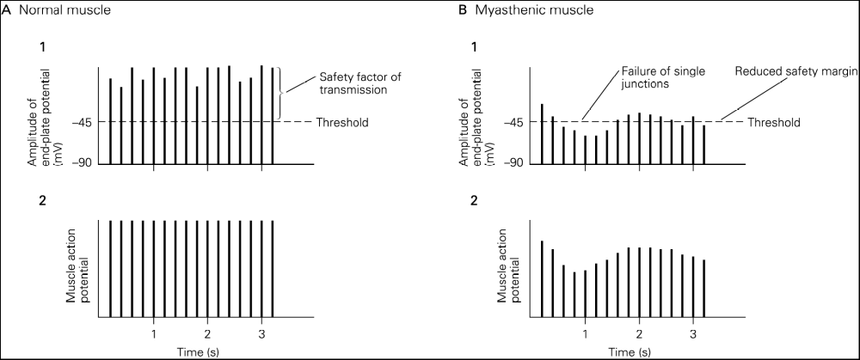

Review for Quiz
- Important to feel comfortable integrating material from Dr. Cooper’s section with material from Dr. Haghighi’s section.
- Capacitative current (I_{c}) + leak current(I_{l}) = synaptic current(I_{syn})
  - Very important to understand how these currents change over the course of an action potential.
  - Review “Postscript” section of chapter 11 in the book (pp.202-205) and know circuit diagrams, see right.
  - Will have to use this concept in the context of what happens at a synapse. (in other words, wont be like Dr. Cooper’s questions)

Practice Questions
- Question 1
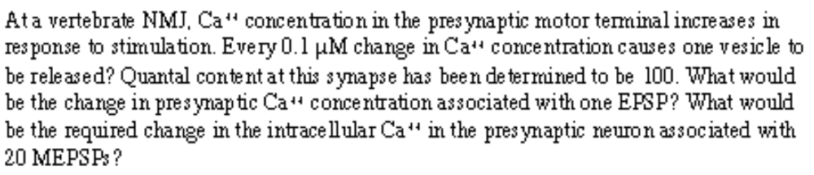
  - Part one: 0.1*100 = 10uM change in Ca++ concentration for one EPSP
  - Part two: MEPSPs are independent of calcium!!!

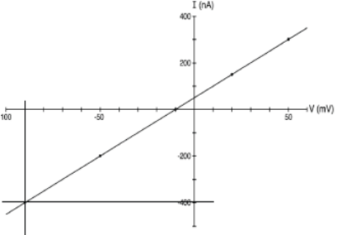
- Question 2
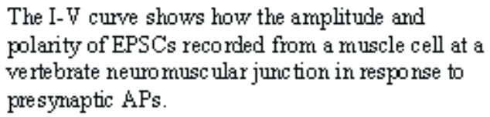
  - Part one:
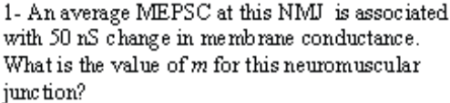

    - Since MEPSCs are spontaneous, pick any point on the IV curve to calculate it.
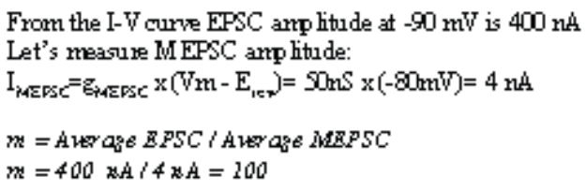

Part Two:

    - Note quantal content (m) would not change in response to AChE because in this scenario the neuron is still releasing the same amount of NT into the cleft, just the AChE is making available in the cleft for longer.
      - This highlights the difference between apparent m and measured m.
    - You must explain why things happen in order to get full credit!

  - Part Three:
